Data Files

The matlab file has the following data:

Velocity ( wheel velocity in m/sec ( at the encoder position ))
Steering ( steering angle in radians with respect to the Forward direction )
Time_VS ( time stamp in seconds for velocity and Steering )

GPSLat ( Latitude in meter with respect to the initial point )
GPSLon ( Longitude in meter with respect to the initial point )
TimeGPS ( Time Stamp in seconds for GPS )

Laser ( 361 observations of range in meters 0.5 degrees apart )
Intensity ( > 0 for a reflector )
TimeLaser (Time stamp in seconds for laser information )

For Implementation purposes we have prepared the following vectors:

Time ( Time stamps for the three sensor from initial time to final time )
Sensor ( 1 : GPS, 2 : Vel and Steering , 3: Laser )
Index ( Index position where the data for this sensor is located )

The user now has to scan the Time vector to get the first data. Time (1) has the time stamp of the data which has taken with Sensor(1), the data is in location Index(1) of the particular sensor.

For example if Time(35)=30.6, Sensor(35) = 2 and Index(35)=6
Implies that
At time 30.6 seconds Velocity and Steering was available and this data is at Velocity(6) and Steering(6)

If Time(35)=30.6, Sensor(35) = 3 and Index(35)=2
At time 30.6 seconds Laser was available and this data is at Laser(2, 1:361);

If Time(35)=30.6, Sensor(35) = 1 and Index(35)=2
At time 30.6 seconds Laser was available and this data is at GPSLat(2) and GPSLon(2)

Vehicle Kinematic Information

According to Figure 1

a = 3.78 m
b = 0.5 m
H=0.76 m
L=2.83 m.
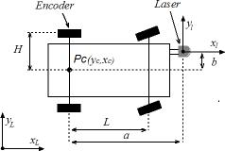
Figure 1 . Vehicle kinematics

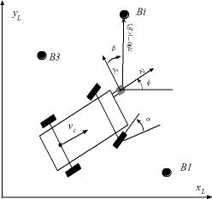
Vehicle and Laser sensor

